Client-Side Honeypot and SSH Security Hardening on Ubuntu
Name: Teppala Pavan Kumar
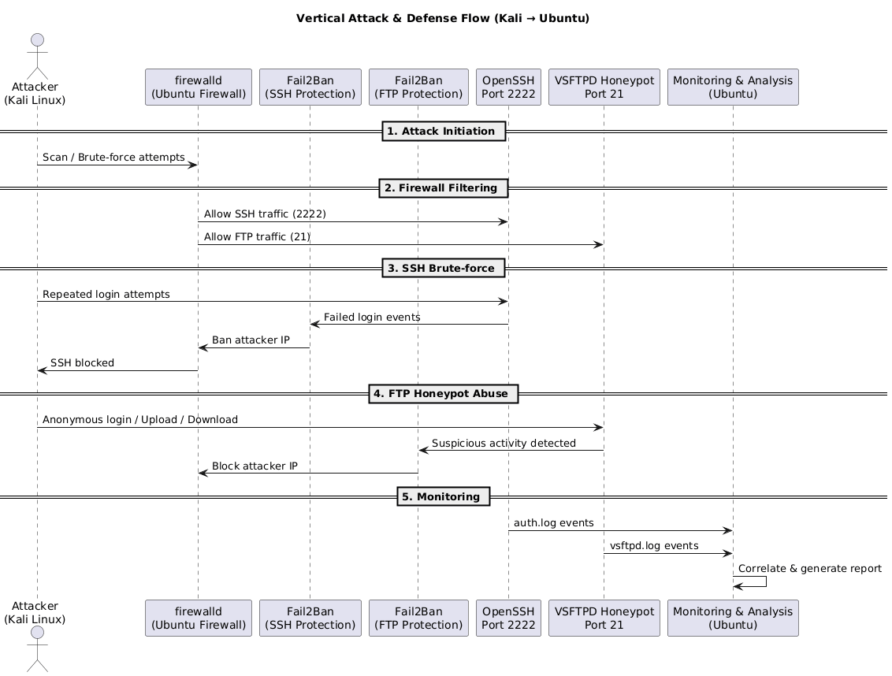

Target Machine (Ubuntu Server): 192.168.43.131
Attacker Machine (Kali Linux): 192.168.43.128

1. Network Verification
The attacker machine successfully pings the Ubuntu server to confirm connectivity before proceeding with security testing.

2. OpenSSH Installation and Configuration
OpenSSH is installed on the Ubuntu server to allow secure remote access. SSH hardening techniques are applied to reduce attack surface.

SSH Hardening Steps
- Change default SSH port from 22 to 2222
- Disable root login
- Limit authentication attempts
- Enable key-based authentication

3. VSFTPD Honeypot Setup
VSFTPD is installed and configured in a honeypot-like setup to observe malicious FTP behavior.

VSFTPD Configuration Summary
listen=YES
listen_ipv6=NO
anonymous_enable=NO
local_enable=YES
write_enable=YES
chroot_local_user=YES
allow_writeable_chroot=YES
local_root=/home/ubuntu
xferlog_enable=YES
log_ftp_protocol=YES
vsftpd_log_file=/var/log/vsftpd.log
ftpd_banner=Welcome to FTP Service

4. Fake Honeypot Files
Fake files and directories are created inside the FTP root directory to lure attackers and log their interaction.

5. Firewalld Configuration
Firewalld is used as the primary firewall for managing SSH and FTP access rules.
- SSH allowed on port 2222
- FTP allowed on port 21

6. Fail2Ban Installation and Configuration
Fail2Ban is configured to protect SSH and VSFTPD services by dynamically banning malicious IPs.

Fail2Ban Jails
- jailssh.conf to protect SSH on port 2222
- vsftpd-honeypot.conf to monitor FTP brute-force attempts

7. SELinux Configuration
SELinux policycoreutils are installed. SELinux mode is set to enforcing to provide Mandatory Access Control (MAC).

8. Attack Monitoring Script
A Python-based monitoring script is created to detect SSH brute-force attempts by parsing authentication logs in real time.

9. Attack Simulation from Kali Linux
Nmap reconnaissance is performed using -sC -sV -A flags. SSH brute-force attempts are simulated using NSE scripts with users.txt and passwords.txt.

10. Detection and Response
The attack is detected by the custom monitoring script and Fail2Ban automatically blocks the attacker IP.

